The following steps guide you to get Windows 10 set up on your virtual box.

**STEP1:** Getting the ISO Image file

**STEP2:**

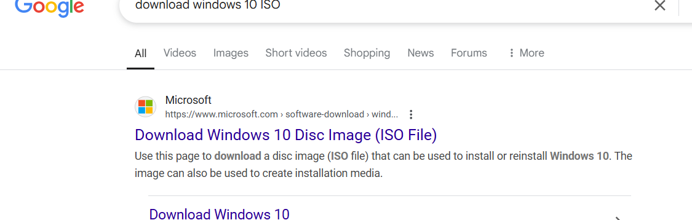

**STEP3:**

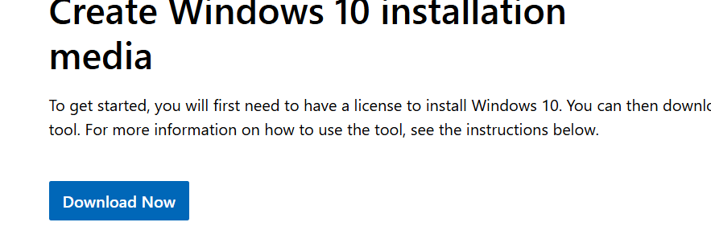

**STEP4: Click on the downloaded file**

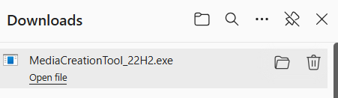

**STEP5:**

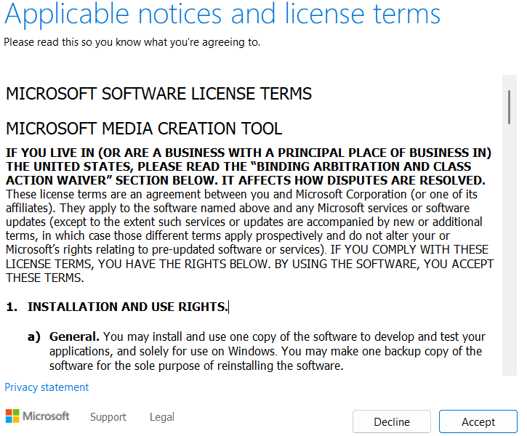

May take a while to finish

**STEP6: Select the second option because you only need the image file**

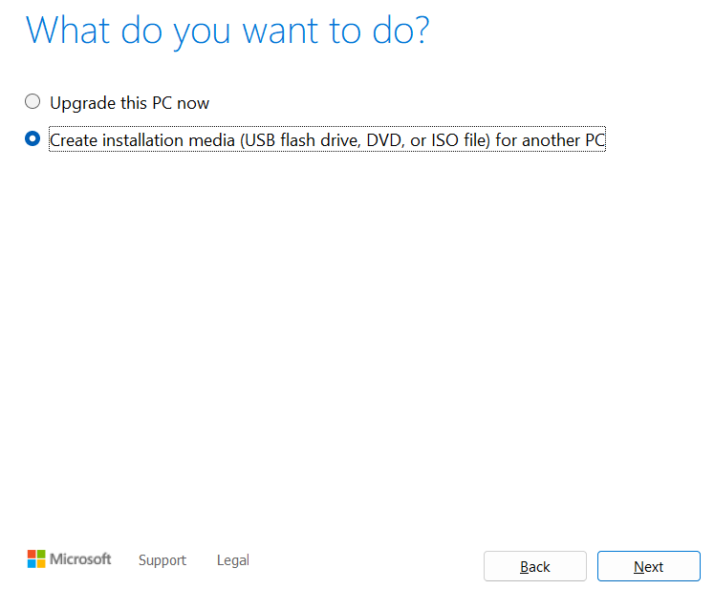

**STEP7:**

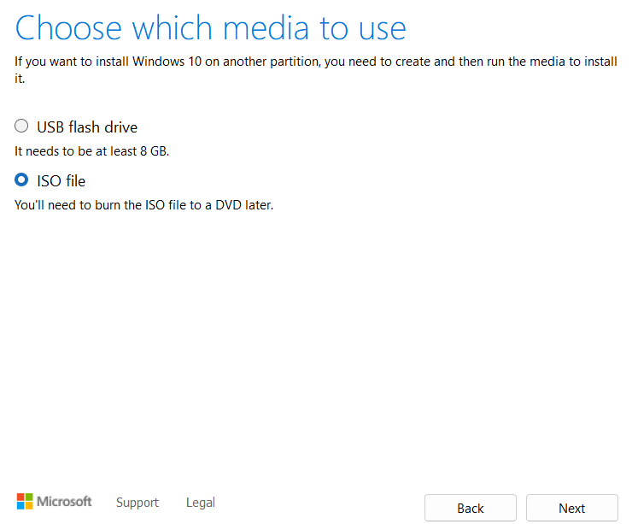

**STEP8:** May take a while to complete (about 3 to 5 mins)

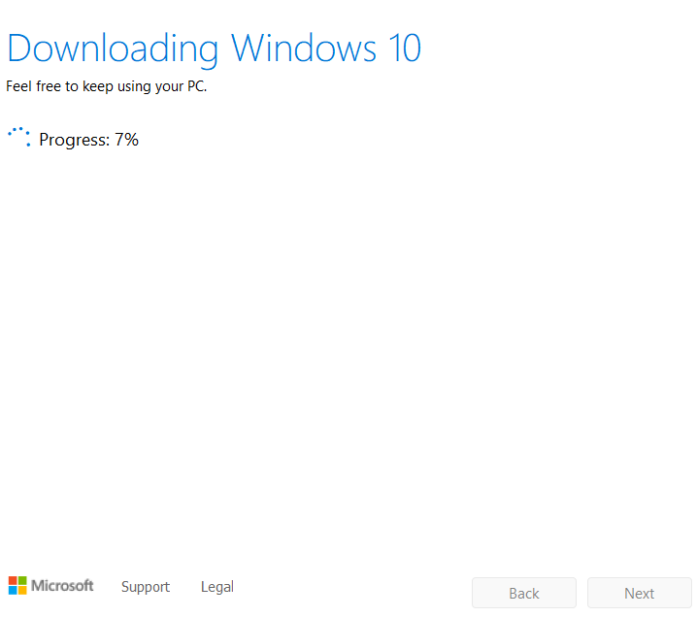

**STEP9: This may take up to 2 mins. Then select storage location. You can choose desktop.**

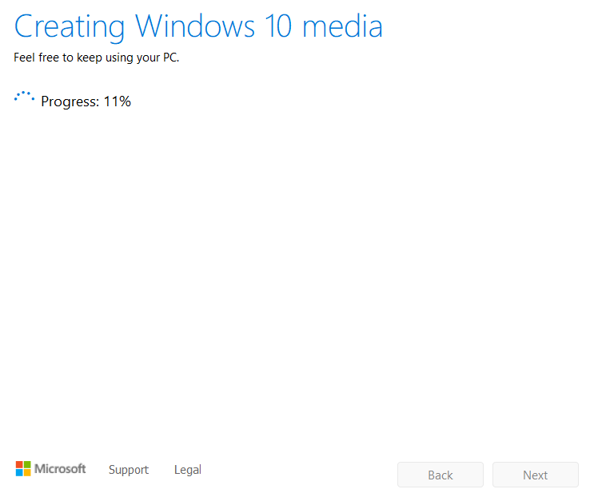

**STEP10: Finish**

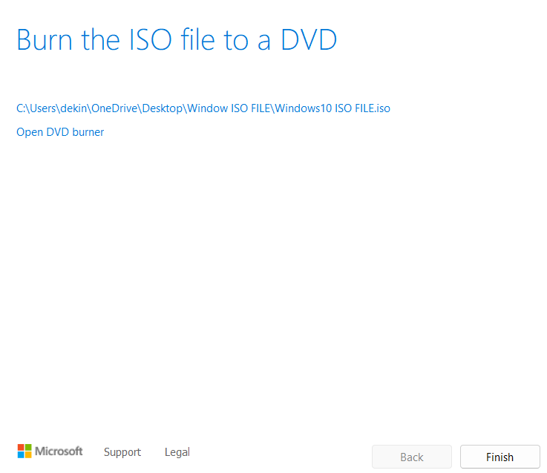

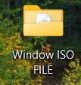 how it looks on desktop

**STEP11: open virtual box and click New**

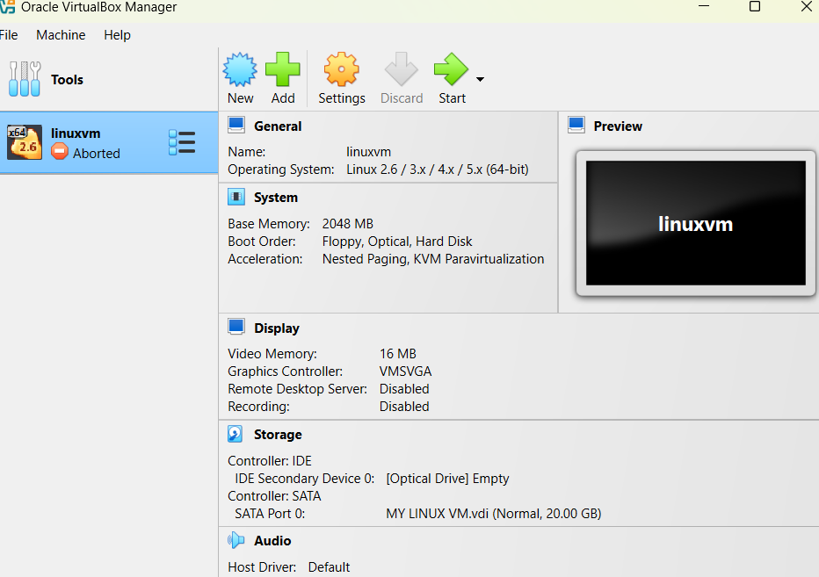

**STEP12: Select the file path to the desktop folder**

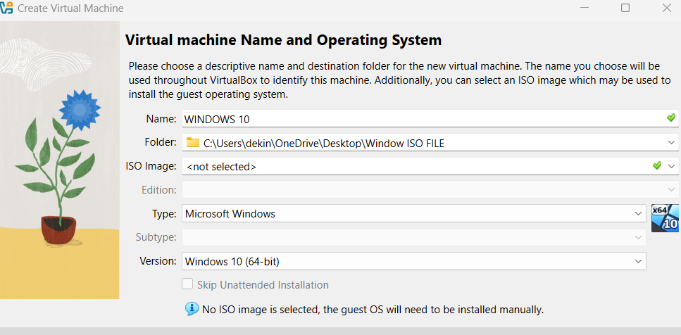

**STEP13: Increase the memory up to 4GB depending on your computer RAM size. You can also adjust the processor**

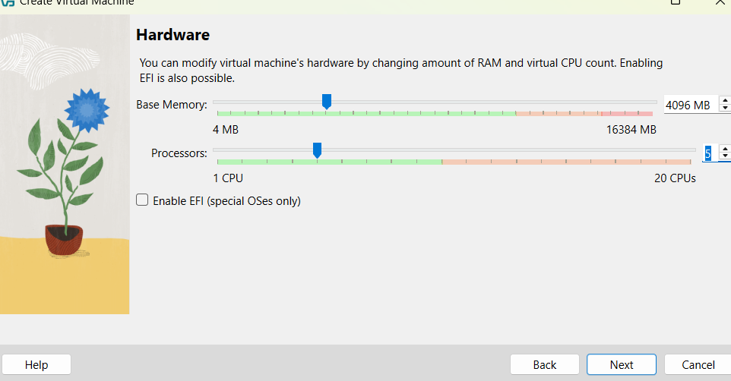

**STEP14: Assign up to 50GB storage space. It starts using up as you add more applications**

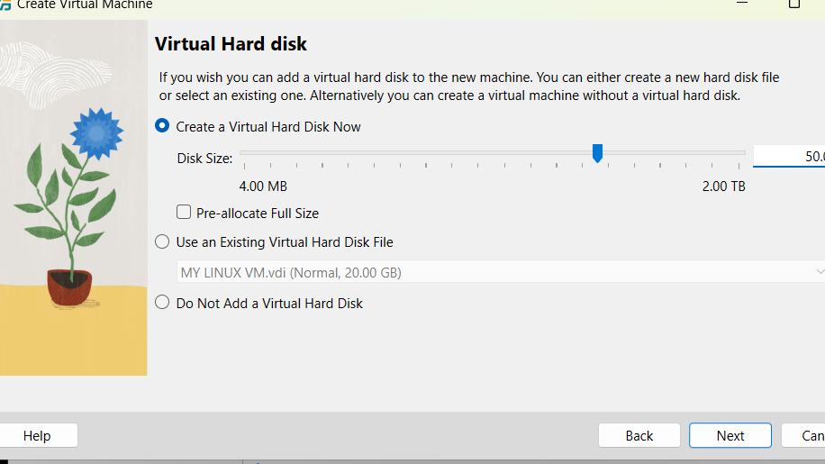

**STEP15: Finish**

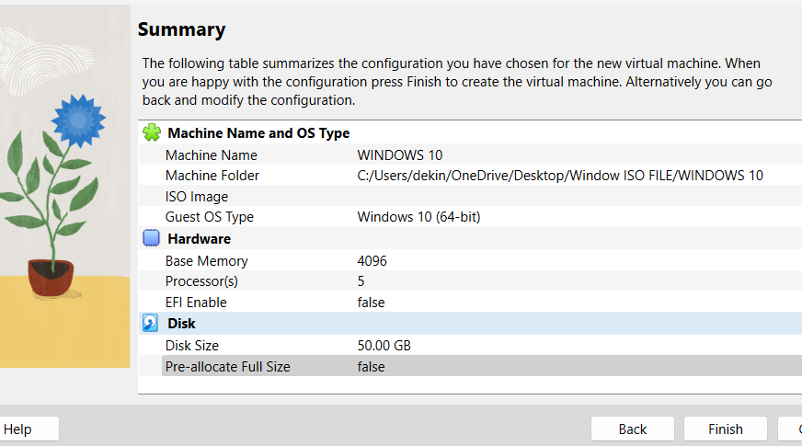

**STEP16:**

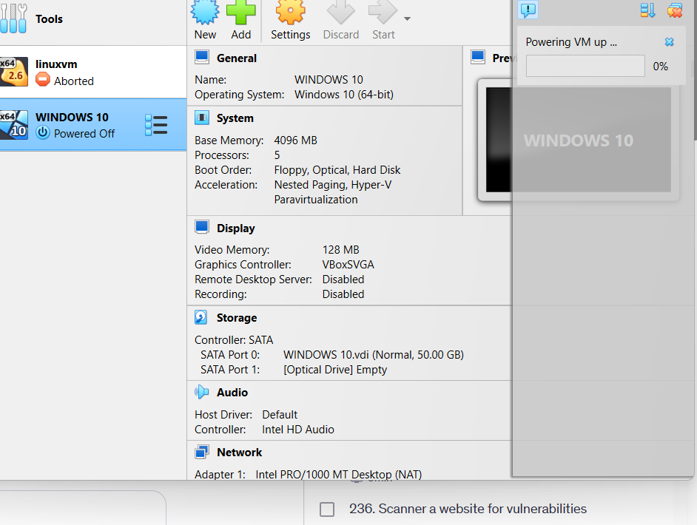

**STEP17:** Cannot start because the ISO file was not found

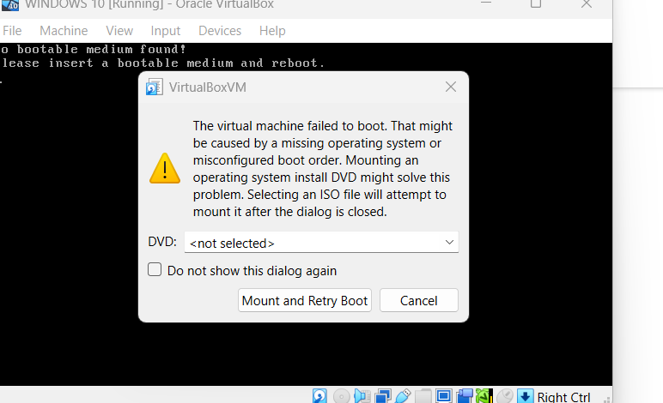

**STEP18: Select the ISO file**

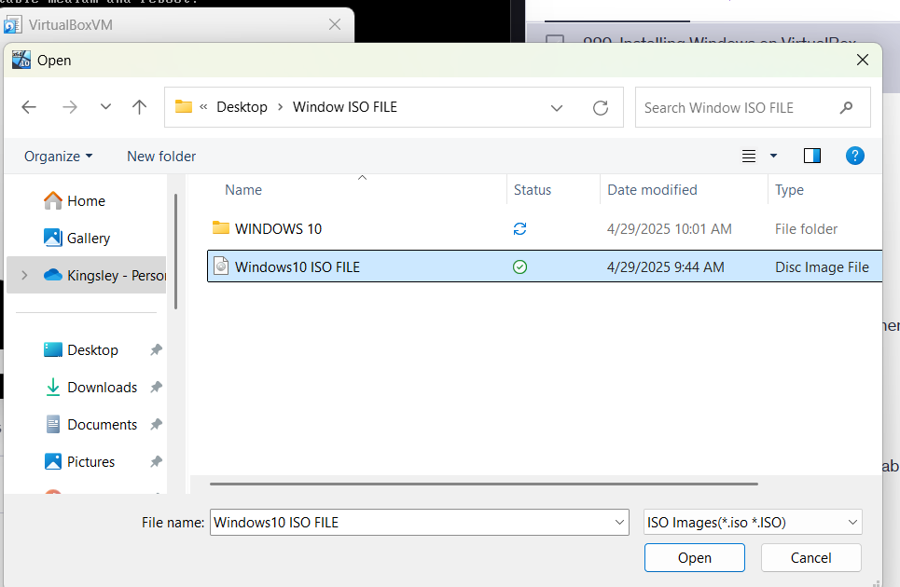

**STEP19: click on Mount and Retry Boot**

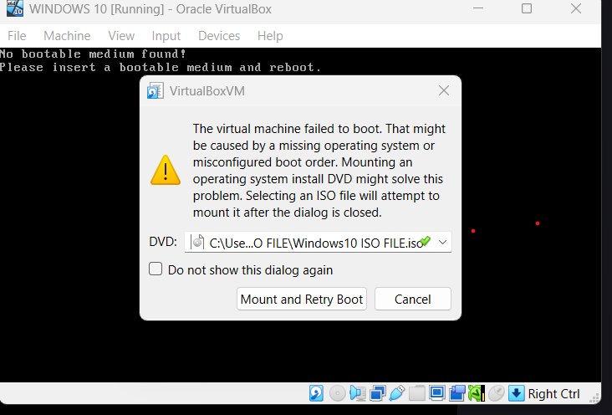

**STEP20: Ready.**

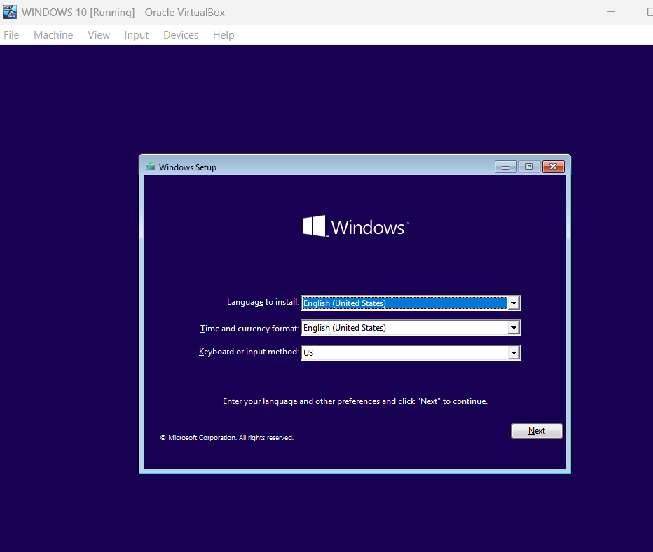

**STEP21: Click on I don’t have product key**

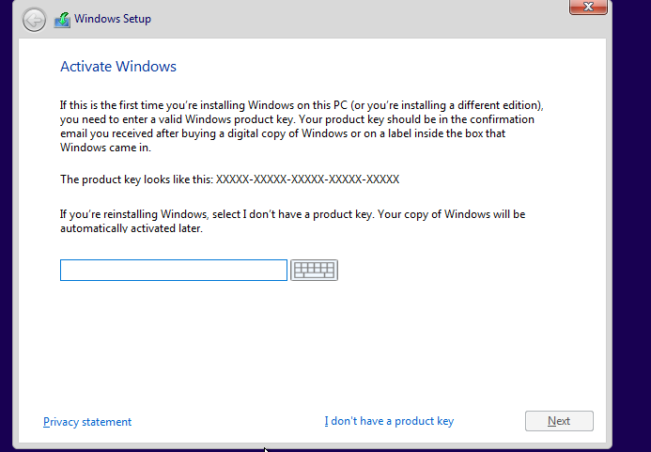

**STEP22: Select Windows 10 Pro**

